OFFICIAL COORDINATION REQUEST FOR
NON-ROUTINE OPERATIONS AND MAINTENANCE

COORDINATION TITLE – 13 IHR 011 Line #1 disconnect maintenance –Revision

****Update to FPP Appendix A and previous Coordination Form 13-IHR-011 shown below as appendix A. Original request July 8, 2013.

COORDINATION DATE – Revised coordination date: September 30, 2013
PROJECT - Ice Harbor Lock and Dam
RESPONSE DATE – FPOM 10 October, 2013

Description of the problem – The Project is requesting to begin Special Project Operations & Studies 1.9. Line #1 Disconnect Maintenance in combination with Main Turbine Unit 1 Annual Maintenance.

From: Appendix A – Special Project Operations & Studies Ice Harbor Dam: 1.9. Line #1 Disconnect Maintenance scheduled for August 2013.

To: scheduled for November 4 - 22

Type of outage required – Perform Main Turbine Unit 1 Annual Maintenance November 4 – 22 and Line 1 disconnect maintenance November 4 – 14. Line 1 will be out of service November 4 – 14.

Impact on facility operation – Main turbine unit 1 will be out of service November 4 -22. Main turbine units 1 and 2 will be out of service during the Line 1 outage November 4 - 14. Turbine priority will be impacted. Switching may not be able to occur to support power generation and BPA system reliability (FPP IH section 4.1 Ice Harbor run as a single or two unit project). If switching does NOT occur, turbine unit priority will be turbine unit 5 then unit 3. This is the period noted in the FPP section 4.3 for the normal annual maintenance timing of priority units.

Dates of impacts/repairs: November 4 – 22.

Length of time for repairs – Approximately 3 weeks.

Expected impacts on fish passage –
Impacts to adult Chinook salmon and steelhead trout fish passage are expected to be minimal at this time. This work will be completed after the latest peak migration timing for both species noted in the FPP Table IHR-2. Juvenile fish migration numbers low during this time period. See table below.

Table IHR-. Adult Counting Periods and Peak Migration Timing at Ice Harbor Dam (based on fish count data from years 1962-2012).
Species | Count Period | Earliest Peak | Latest Peak
Spring Chinook | 4/1 – 6/11 | 4/22 | 5/26
Summer Chinook | 6/12 – 8/11 | 6/12 | 7/23
Fall Chinook | 8/12 – 10/31 | 9/2 | 9/30
Steelhead | 4/1 – 10/31 | 9/15 | 10/12
Sockeye | 4/1 – 10/31 | 7/1 | 9/22
Lamprey | 4/1 – 10/31 | 7/21 | 9/3

Comments from agencies:

Final results

Please email or call with questions or concerns.
Thank you,

Mark Plummer
Ice Harbor Project Fisheries Biologist

Appendix A

OFFICIAL COORDINATION REQUEST FOR
NON-ROUTINE OPERATIONS AND MAINTENANCE

COORDINATION TITLE – 13 IHR 011 Line #1 disconnect maintenance COORDINATION DATE – July 8, 2013
PROJECT - Ice Harbor Lock and Dam
RESPONSE DATE – 12 July 2013

Description of the problem – The Project is requesting to begin Special Project Operations & Studies 1.9. Line #1 Disconnect Maintenance ahead of time frame noted in FPP Appendix A.

From: Appendix A – Special Project Operations & Studies
Ice Harbor Dam: 1.9. Line #1 Disconnect Maintenance. Scheduled in August (Page A-19)

To: July 17 – July 26

Type of outage required – Taking Line 1 out of service.

Impact on facility operation – Main turbine units 1 and 2 will be out of service. Turbine priority impacted. This is the period noted in the FPP section 4.3 for annual maintenance on units – mid July.

Dates of impacts/repairs: July 17 – July 26

Length of time for repairs – Approximately 2 weeks.

Expected impacts on fish passage –
Impacts to adult Chinook salmon and steelhead trout fish passage are expected to be minimal at this time. This work will be completed between adult fish runs. Juvenile fish migration numbers low during this time period. See graphs below.

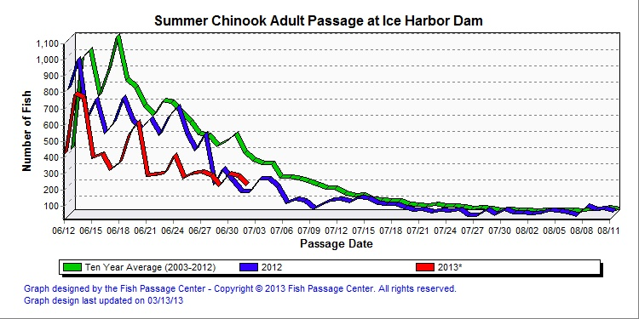

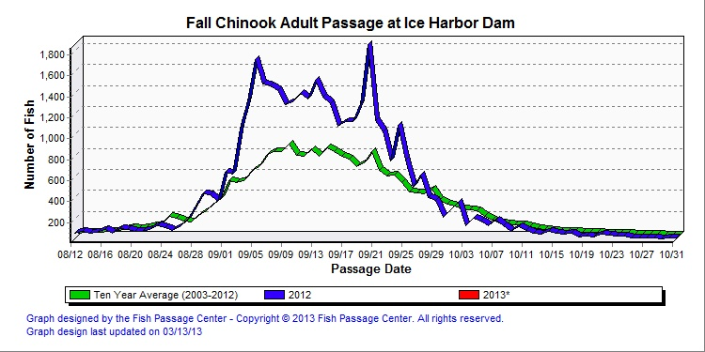

Comments from agencies:
13IHR011 Line 1 disconnect maintenance. Need the extra time to work on the disconnect prior to the doble testing. Conder doesn’t like this operation. He would like to see the work in August since steelhead could take the delay a little better than the Chinook. Conder also expressed concern about the MOC structure; it was vague, needed more in-depth analysis of the impacts by species, no reference to the previous coordination, dates were changed and there was no explanation as to why. Moody said this work cannot be delayed due to the annual maintenance scheduled after this work and if it isn’t done now, the doble testing won’t be completed for another 3 years. FPOM asked how late the disconnect maintenance could be pushed, how soon could doble testing occur. NOAA said no. This is ESA listed sockeye at risk during this operation. Moody asked if doing the disconnect after 26 July would be acceptable. NOAA said that would be better and as close to August is best. NOAA and CRITFC does not support this MOC as written. There are concerns about impacts to sockeye. BPA will work with NWW to figure out scheduling. ACTION: Moody will go back to the PM and work with developing a new schedule.
From: Thoren, Scott D NWW
Sent: Thursday, July 11, 2013 1:08 PM
To: Dougan, Joshua L NWW; Golladay, Roger M NWW; Ross, Jerry E NWW; Thompson, Seth J NWW; Plummer, Mark F NWW; DLL-CENWW-ICE CONTROL ROOM; Eickmann, Greg A NWW; Goodall, Tod L NWW
Cc: Moody, Gregory P NWW
Subject: Fw: Doble Testing / Line 1 disconnect (UNCLASSIFIED)

All,
The annual maintenance for unit 1 was not approved by FPOM for next the next three weeks. The existing approval to perform Doble testing during the week of 22 July is still approved.
Taking unit 1 OOS for annual maintenance from 15 July through 1 August is not approved.
The request to take line 1 OOS early (17 July) was not approved either.
The path forward that I see right now is to perform Doble testing the week of 22 July. We will have to reschedule the unit 1 annual maintenance, probably for November timeframe.
From what I can tell, the Doble testing was approved and an assumption was made that the corresponding unit 1 outage would move as well. This was not the case, only the doble testing was approved.
FPOM is ok with extending the outage into the following week to accomplish line disconnect work (will need to coordinate with BPA). Main issue is an early sockeye (ESA listed) run.
Josh, would you rework a proposed schedule with coordination points I'd'ed (BPA swicthing or transfer trip manipulations)?
Thanks,
Scott
---------------------------------------------
Sent from my Blackberry device.
From: Moody, Gregory P NWW
Sent: Thursday, July 11, 2013 12:36 PM Pacific Standard Time
To: Lut,Agnes (BPA) - KEWR-4 <axlut@bpa.gov>; BPA Scott Bettin
Cc: Petersen,Christine H (BPA) - KEWR-4 <chpetersen@bpa.gov>; Thoren, Scott D NWW
Subject: RE: Doble Testing / Line 1 disconnect (UNCLASSIFIED)
Classification: UNCLASSIFIED
Caveats: NONE
FPOM doesn’t mind the July 22 to July 26 day as coordinated / approved for doble testing.
The new request from IH (13 IHR 011) is to move Line 1 disconnect work to July 15. This was not approved by FPOM. There is the problem with sockeye fish passage at this time. FPOM indicated it could be done after doble testing - 26 July. It would be better for fish passage.
Scott Thoren needs to confirm if this can be done at the IH project level first before we go forward. He has tentatively indicated the project could comply.

I understand about the BPA crews.

Do not know Trevor’s changes for LGS. It was approved as written for exciter testing in October November.

Greg

From: Lut,Agnes (BPA) - KEWR-4 [mailto:axlut@bpa.gov]
Sent: Thursday, July 11, 2013 11:52 AM
To: Moody, Gregory P NWW; BPA Scott Bettin
Cc: Petersen,Christine H (BPA) - KEWR-4
Subject: Doble Testing / Line 1 disconnect

Greg
I was on the phone for FPOM and the issue Trevor Condor had regarding Doble Testing and Line 1 disconnect was kinda fuzzy… the details, not the fact that he was unhappy with the current path forward even though we began coordination on this issue months ago (March, according to the conversation).
Can you give Scott an overview of the date change request that Trevor is suggesting for LGS Unit outages / testing?
Scott’s out of the office today, and I like him to be briefed on this issue…
It seems unlikely that we will be able to remobilize crews in such a short notice…

Seems like Trevor wants the testing and Line 1 disconnect to occur in late Aug, about the 22nd , instead of this month (July), but I didn’t catch when the July testing was going to take place.

Agnes Lut
Fish Biologist, Hydro Team - Policy and Planning
Bonneville Power Administration, KEWR-4
905 NE 11th Ave, Portland, OR 97232

Ph: 503-230-5651
Cell: 971-271-4784
axlut@bpa.gov

